*Group 36*



*Chris Rayan*

[cr1g19@soton.ac.uk](mailto:cr1g19@soton.ac.uk)

*Eli Stamenova*

[es1u19@soton.ac.uk](mailto:es1u19@soton.ac.uk)

*Ivan Tsvetanov*

[it4u19@soton.ac.uk](mailto:it4u19@soton.ac.uk)

*Katrin Borisova*

[kb1g19@soton.ac.uk](mailto:kb1g19@soton.ac.uk)

COMP1216

Software Modelling and Design

*(2019-2020)*

Coursework 1: Requirements Analysis, Specification, and Design

**1 INTRODUCTION**

In this assignment we analyse the requirements, specification and design to build an interactive quiz system. Our work will be conducted in multiple steps:

* **Step 1**: Defining the scope of the system [1] and creating two full operational scenarios [2].
* **Step 2**: Writing two full use case descriptions (3) and creating a use case diagram (4).
* **Step 3**: Creating a class diagram [5] and an activity diagram [7].
* **Step 4**: Creating two sequence diagrams [6], corresponding to the two scenarios defined in [2].

**2 COMMENTS**

**Step 1** is done by *Chris Rayan*.

**Step 2** is done by *Katrin Borisova*.

**Step 3** and the ***Introduction*** are done by *Ivan Tsvetanov*.

**Step 4** is done by *Eli Stamenova*.

**3 DEFINING THE SCOPE OF THE INTERACTIVE QUIZ SYSTEM**

***Need:***

The University is finding that the standard of current quiz websites available online, such as Kahoot and Vevox, are not quite satisfactory for use as a purely teaching tool within lectures.

***Goals:***

For the University to develop its own interactive quiz system in order to allow complete control over the features included, in turn improving the quality of teaching in lectures for students using the system.

***Business Case:***

Remove the reliance on third-party websites, instead providing an interactive quiz system standardised by the University itself.

***Stakeholders:***

Future and existing students, lecturers, iSolutions (IT Department), the University.

***High-level Operational Concepts:***

* Users can **register** with their desired username and password.
* Registered users can create quizzes with multiple multiple-choice questions.
* A quiz question can have 2,3 or 4 options, with a single correct answer.
* Users can edit their own quizzes after they are created.
* Users can share their created quizzes with other registered users.
* Registered users can **initiate** quizzes of their own or quizzes shared with them, becoming the **host** of that quiz session.
* Initiating a quiz session will generate a unique ID number.
* Any user can use an ID number to join an initiated quiz, becoming a **player**.
* When the host is satisfied with the number of players, they can **begin** an initiated quiz to go through each question with a predefined timeout.
* A question can be terminated early by a host, or if all players have answered, or if the predefined timeout for the question is up.
* After each question, all players can see a summary of the answers, and the host can start the next question.
* When a quiz completes, a report is produced and displayed to users involved.
* A host will have the quiz report stored in their account.

***Assumptions:***

Users will interact with the system through either a computer, smartphone, or tablet.  ***Constraints:***

Develop the system within 6 months, with a budget of £5,000.

**4 OPERATIONAL SCENARIOS**

**4.1 Operational Scenario I**

1. A registered user logs into the system with their username and password.
2. User is shown a summary of their created quizzes and quizzes shared with them.
3. User chooses to create a new quiz with multiple-choice questions.
4. Question creation:

* User can write 2 to 4 options to choose from, with one correct answer.

1. User repeats **4.** until they choose to finish creating the quiz.
2. User is returned the summary of quizzes.
3. User selects their newly created quiz
4. User chooses to share this quiz.
5. User is prompted with a dialog box to enter the username of another registered user to share with.
6. User shares the quiz and logs out of the system.

**4.2 Operational Scenario II**

1. A registered user logs into the system with their username and password.
2. User is shown a summary of their created quizzes and quizzes shared with them.
3. User selects a quiz.
4. User chooses to initiate this quiz, becoming the host of the session.
5. The initiated quiz generates a unique ID number.
6. The host shares the ID so other registered users can join the quiz.
7. Other users join the quiz as players by entering the corresponding ID number.
8. The host chooses to begin the quiz.
9. The players answer the question shown.

* Once the question is over, users are shown a summary of the chosen answers and the correct answer.

1. **7.** is repeateduntil all questions have been answered.
2. A report of the quiz is generated and displayed to all users involved.
3. Host has the report stored in their account.
4. User logs out of the system.

**7** **A CLASS DIAGRAM FOR THE INTERACTIVE QUIZ SYSTEM**

The purpose of this UML class diagram is to display the *structure* of the interactive quiz system. The diagram presents the different classes, their attributes, methods and relationships among them, all in a graphic and easy to read format. The diagram will be used as a conceptual model when building the application.

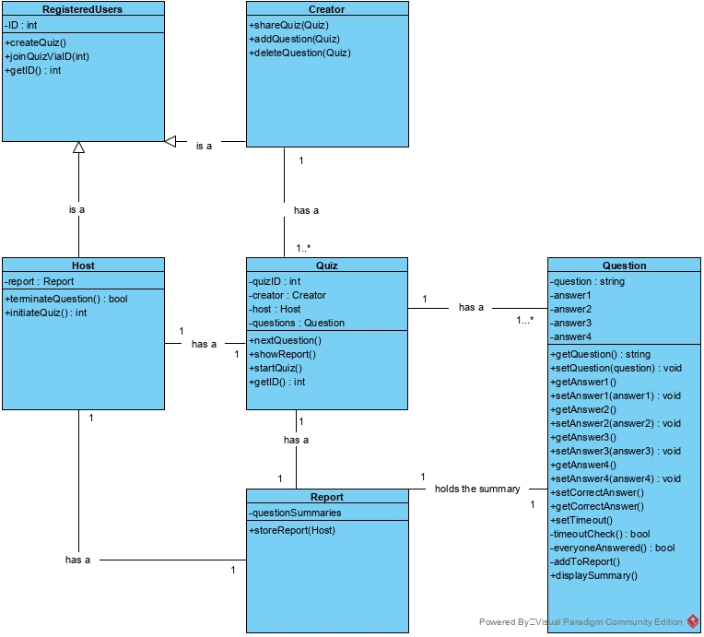

**8** **TWO SEQUENCE DIAGRAMS CORRESPODING TO THE TWO OPEARTIONAL SCENARIOS (SEE PART 4** [2]**)**

**8.2 SEQUENCE DIAGRAM II**

**9** **AN ACTIVITY DIAGRAM FOR THE RUNNING A QUIZ**

